Progression in Calculations Policy

At the centre of the mastery approach to the teaching of mathematics is the belief that all pupils have the potential to succeed. Children should all have access to their age-appropriate curriculum content and, rather than being extended with new learning, they should deepen their conceptual understanding by tackling varied and challenging problems. Similarly, with calculation strategies, pupils must not simply rote learn procedures but demonstrate their understanding of these principles and concepts through the use of concrete materials and pictorial representations to ensure fluency and depth of understanding.
The rationale of the concrete-pictorial-abstract (CPA) approach is that for pupils to have a true understanding of a mathematical concept, they need to master all three phases. Reinforcement is achieved by going back and forth between these representations. Pupils who grasp concepts rapidly should be challenged through rich and sophisticated problems before any acceleration through new content. Those pupils who are not sufficiently fluent with earlier material should consolidate their understanding, including additional practice, before moving on.
There is also an emphasis placed on instant recall of number bonds and times tables. These need to be mastered to aid with calculations and more challenging problems in readiness for the Multiplication Test at the end of Year 4.
This document outlines the progression of different calculation strategies that could be taught and used from Reception – Year 6, in line with the requirements of the 2014 Primary National Curriculum.
This guidance is to make teachers and parent/carers aware of the progression of strategies that pupils are formally taught that will support them to perform mental and written calculations. In addition, it will support teachers in identifying appropriate pictorial representations and concrete materials to help develop understanding. We have assigned objectives to year groups based upon National Curriculum expectations.
However, it is important to remember that it may sometimes be necessary to revisit strategies from previous year groups if children are working below age related expectations.
This guidance only details the strategies; teachers must plan opportunities for pupils to apply these. Concrete materials shown here are for exemplification; there are many other resources which can be used to aid pupil understanding.
Ideas and images have been derived from The White Rose Calculation Policy, Ark Maths Mastery Documentation and NCETM materials

This calculation progression document is based on key mastery principles as outlined in the diagram below:

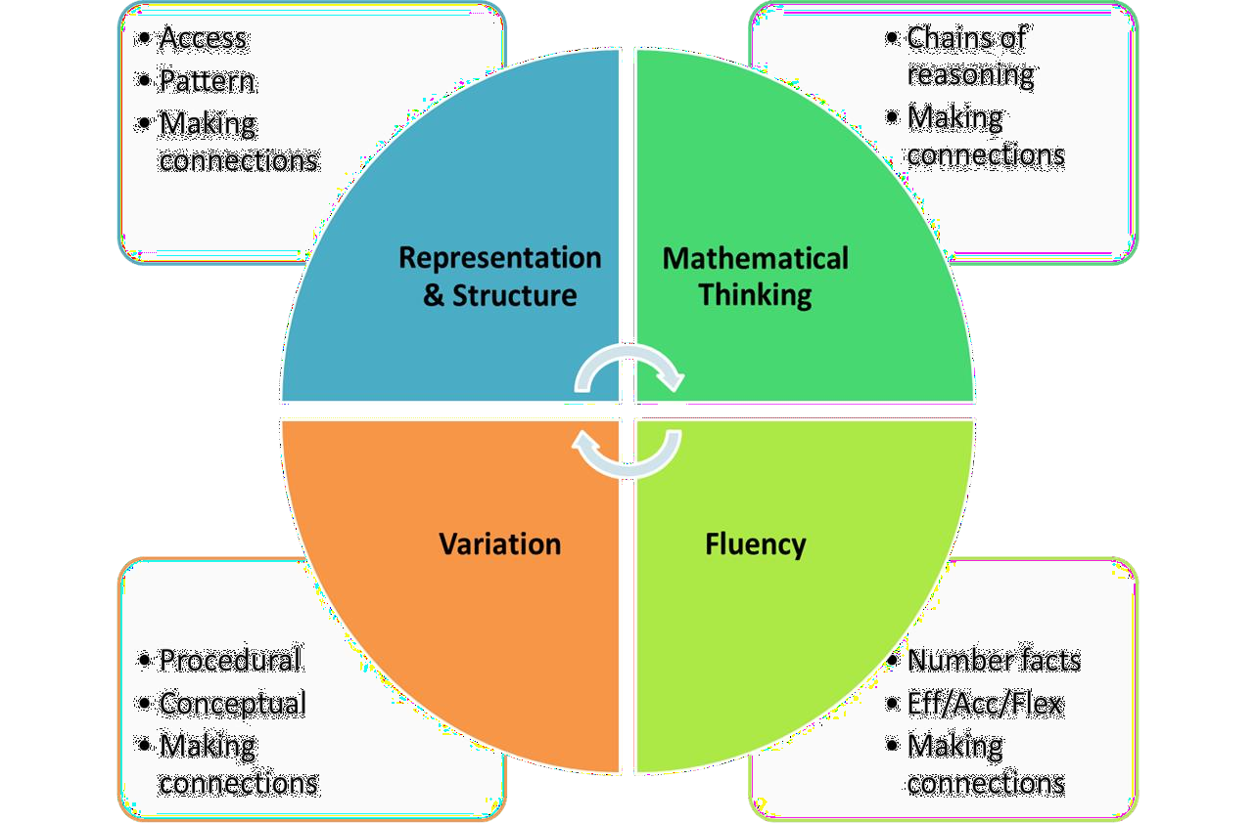

Progression in each calculation

 | Year R | Year 1 | Year 2 | Year 3 | Year 4 | Year 5 | Year 6
Addition | Counting a set of objects.  Knowing 1 more  Place numbers in order of size  Have a deep understanding of number to 10, including the composition of each number.  Have automatic recall of all number bonds to 5 and some to 10  Subitise up to 5  Compare quantities up to 10 indifferent contexts using the language greater than/less than and equal.  Counting verbally beyond 20, recognizing the pattern of the counting e.g 11 comes after 10 and then 12. | Combining two parts to make a whole: part whole model  Starting at the bigger number and counting on  Regrouping to make 10 | Adding three single digits.  Column method – no regrouping | Column method- regrouping.  (up to 3 digits) | Column method- regrouping.  (up to 4 digits) | Column method- regrouping.  (with more than 4 digits)  (Decimals- with the same amount of decimal places) | Column method- regrouping. (Decimals- with different amounts of decimal places)
Subtraction | Knowing one less than / Taking away ones  Subitise up to 5  Have automatic recall of all number bonds to 5 and some to 10  Compare quantities up to 10 indifferent contexts using the language greater than/less than and equal. | Taking away ones Counting back Find the difference Part whole model Make 10 | Counting back Find the difference Part whole model Make 10  Column method- no regrouping | Column method with regrouping. (up to 3 digits) | Column method with regrouping. (up to 4 digits) | Column method with regrouping. (with more than 4 digits)  (Decimals- with the same amount of decimal places) | Column method with regrouping. (Decimals- with different amounts of decimal places)
Multiplicatio | Know doubles of numbers up to 5 | Doubling  Counting in multiples Arrays (with support) | Doubling Counting in multiples Repeated addition Arrays- showing commutative  multiplication | Counting in multiples Repeated addition Arrays- showing commutative multiplication  Grid method | Column multiplication  (2 and 3 digit  multiplied by 1 digit) | Column multiplication  (up to 4 digit numbers multiplied by 1 or 2 digits) | Column multiplication  (multi digit up to 4 digits by a 2 digit number)
Division | Distribute quantities up to 10 equally | Sharing objects equally Division as grouping | Division as grouping Division within arrays | Division within arrays  Division with a remainder Short division (2 digits by 1 digit- concrete and pictorial) | Division within arrays  Division with a remainder  Short division (up to 3 digits by 1 digit- concrete and pictorial) | Short division  (up to 4 digits by a 1 digit number interpret remainders appropriately for the context) | Short division Long division  (up to 4 digits by a 2 digit number- interpret remainders as whole numbers, fractions or round)

Mathematical language

The 2014 National Curriculum is explicit in articulating the importance of children using the correct mathematical language as a central part of their learning. Indeed, in certain year groups, the non-statutory guidance highlights the requirement for children to extend their language around certain concepts.
The quality and variety of language that pupils hear and speak are key factors in developing their mathematical vocabulary and presenting a mathematical justification, argument or proof.
2014 Maths Programme of Study
It is therefore essential that teaching using the strategies outlined in this policy is accompanied by the use of appropriate mathematical vocabulary. New vocabulary should be introduced in a suitable context (for example, with relevant real objects, apparatus, pictures or diagrams) and explained carefully.

High expectations of the mathematical language used are essential, with teachers only accepting what is correct.

Correct | Incorrect
ones | units
is equal to | equals
zero | oh  (the letter O)

The expectation is that pupils will, at all times, answer in full sentences.
say, you say, you say, you say, we all say

This technique enables the teacher to provide a sentence stem for children to communicate their ideas with mathematical precision and clarity. These sentence structures often express key conceptual ideas or generalities and provide a framework to embed conceptual knowledge and build understanding. For example:

If the rectangle is the whole, the shaded part is one third of the whole.

Having modelled the sentence, the teacher then asks individual children to repeat this, before asking the whole class to chorus chant the sentence. This provides children with a valuable sentence for talking about fractions. Repeated use helps to embed key conceptual knowledge.
Sentence stems can be used to help pupils with this if required.

Acceptable | Not acceptable
The answer is 17 | 17
9 multiplied by 3 is 27 | 27

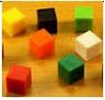
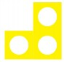
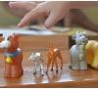

Addition

Yr/ Step | Strategy/ Method | New Vocabulary for  the Stage | Concrete | Pictorial | Abstract
Step 1  Yr R | Counting a set of objects  Knowing 1 more or 1 less  Place numbers in order of size | One more One less Bigger Larger |  | 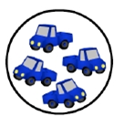 | 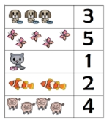
Step 2  Yr R + 1 | Combining two parts to make a  whole: part-whole model | Addition Sum Total Parts and wholes Plus  Add  Altogether More than Equal to Same as | Use cubes to add two numbers together as a group or in a bar:  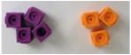  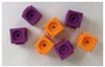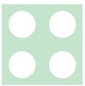  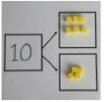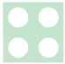  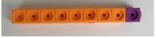 | Use pictures to add two numbers together as a group or in a bar:  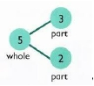    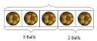 | Use the part-part whole diagram as shown to move into the abstract:  5  3  4 + 3 = 7  10 = 6 + 4





Yr/  Step | Strategy/  Method | New Vocabulary  for the Stage | Concrete | Pictorial | Abstract
Step 3  Yr 1 | Start at the bigger number and count on |  | 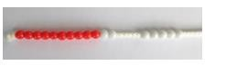  Start with the larger number on the bead string and then count on to the smaller number 1 by 1 to find the answer. | Start at the larger number on the number line and count on in ones or in one jump to find the answer.  12 + 5 = 7  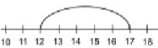 | Place the larger number in your head and count on the smaller number to find your answer.  5 + 12 = 17
Step 4  Yr 1 | Regrouping to make 10 | Regroup Partition | Regroup 9 + 3 into 10 + 2 before adding together:  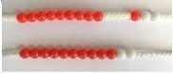  Start with the larger number and use the smaller number to make 10  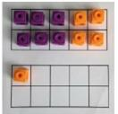 6 + 5 = 11 | Use pictures or a number line.  Regroup or partition the smaller number to make 10 before adding.  3 + 9 =  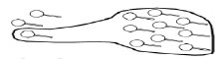  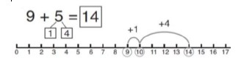 | 7 + 4 = 11  If I am at seven, how many more do I need to make 10?  How many more do I add on now?  7 + 5 = 7 + 3 + 2 = 12
Children move on to using an ‘empty number line’.
E.g. 7 + 5 becomes 7 + 3 + 2
 |  |  |  | 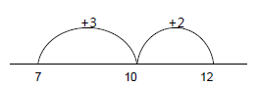

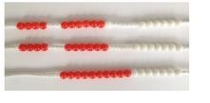
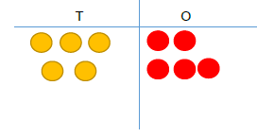
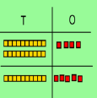
Yr/  Step | Strategy/  Method | New Vocabulary  for the Stage | Concrete |  |  |  | Pictorial | Abstract
Step 5  Yr 2 | Adding three single digits | Addition Sum Total  Parts and wholes Plus  Add  Altogether More than Equal to Same as | 4  P  o  Fo 1  th | + 7 + 6= 17  ut 4 and 6 together to make 10. Add  n 7.  llowing on from making 10, make 0 with 2 of the digits (if possible)  en add on the third digit. |  |  | 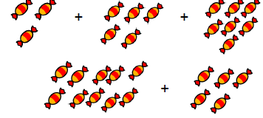  Add together three groups of objects. Draw a picture to recombine the groups to make 10. | 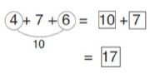  Combine the two numbers that make 10 and then add on the remainder.
Step 6  Yr 2 | Column addition – without  regrouping | Regroup Partition | Partition the numbers into tens and ones using base 10 blocks, place value counters.  Add together the ones first then add the tens. Finally add the 2 totals  together.  24 + 15 = 39 |  |  |  | After practically using the base 10 blocks and place value counters, children can draw the counters to help them to solve additions.  32 + 23 = 55 | 21 + 42 =  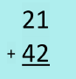  Record the calculation vertically adding the column of ones then the column of tens.
Step 6  Yr 2 | Column addition – without  regrouping | Regroup Partition |  |  |  | 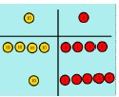
Step 6  Yr 2 | Column addition – without  regrouping | Regroup Partition | 44 + 15 = 59

Yr/  Step | Strategy/  Method | New Vocabulary  for the Stage | Concrete | Pictorial | Abstract
Step 7  Yr 3 (3  digits)  Yr 4 (4  digits)  Yr 5 + (4+  digits and  decimals with same np. dp)  Yr 6  (decimals with difft no. dp) | Column addition – with regrouping | Exchange Regroup Partition | Make both numbers with place value counters.  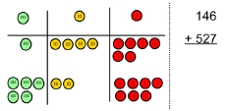  Add up the ones and exchange 10 ones for one 10. Add it to the other tens:  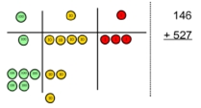  Add up the rest of the columns, exchanging the 10 counters from one  column for the next place value column until every column has been added.  This can also be done with Base 10 to help children clearly see that 10 ones equal 1 ten and 10 tens equal 100.  As children move on to decimals, money and decimal place value  counters can be used to support learning. | Children can draw a pictoral  representation of the columns and place value counters to further support their  learning and understanding.  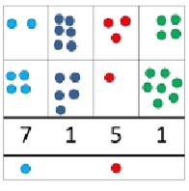 | Begin by partitioning the numbers:  For 76 + 47  70 + 6  40 + 7  110 + 13 = 123  Move on to clearly show the exchange below the addition:  70 + 6  40 + 7  120 + 3 = 123  10  This then becomes the compact method where numbers aren’t partitioned but exchanges still take place:  76  + 47  123  1 1  As the children move on, introduce decimals with and without the same number of decimal places. Money can also be used here.

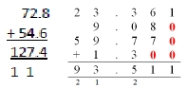

N.B. Exchanged digits need to be recorded below the line when adding.



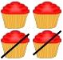
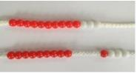
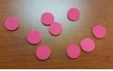
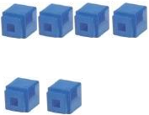
Subtraction

Yr/  Step | Strategy/  Method | New Vocabulary  for the Stage | Concrete | Pictorial | Abstract
Step 1  Yr R Yr 1 | One less than / Taking away ones | One less Take away Less than  The difference Subtract  Minus Fewer Decrease | Use physical objects, counters, cubes numicon, etc, to show how objects can be taken away.  6 – 2 = 4 | Cross out drawn objects to show what has been taken away.  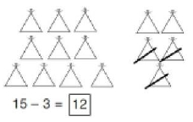  4 – 2 = 2 | 18 – 3 = 15  8 – 2 = 6  Although number sentences are recorded in the concrete and pictorial methods children are introduced to them on their own while encouraging them to mentally take away ones.
Step 2  Yr R Yr 1  Yr 2 | Counting back | One less Take away Less than  The difference Subtract  Minus Fewer Decrease | Make the larger number in your  subtraction. Move the beads along your bead string as you count backwards in ones.  13 – 4  Use counters and move them away from the group as you take them away  counting backwards as you go. | Count back on a number line or number track  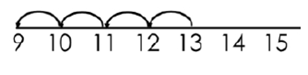  Start at the bigger number and count back the smaller number showing the jumps on the number line.  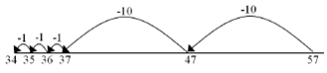  This can progress all the way to counting back using two 2 digit numbers. | For 13 – 4, put 13 in your head and count back 4.  What number are you at? Use your fingers to help.


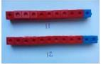
Yr/  Step | Strategy/  Method | New Vocabulary  for the Stage | Concrete | Pictorial | Abstract
Step 3  Yr 1  Yr 2 | Find the difference | One less Take away Less than  The difference Subtract  Minus Fewer  Decrease | Compare amounts and objects to find the difference.  Use cubes to build  towers or make bars to find the difference.  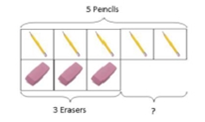  Use basic bar models with items to find the difference. | Count on to find the difference:  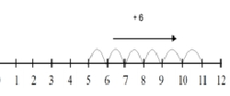  Draw bars to find the difference between 2 numbers.  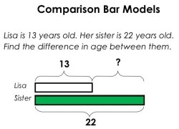 | Hannah has 23 sandwiches, Helen has 15 sandwiches. Find the difference between the number of sandwiches.
Step 4  Yr 1  Yr 2 | Part Whole Model | Part Whole  Inverse | Link to addition - use the part whole model to help explain the inverse between addition and subtraction.  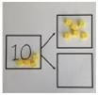  If 10 is the whole and 6 is one of the parts. What is the other part?  10 – 6 = | Use a pictorial representation of objects to show the part whole model.  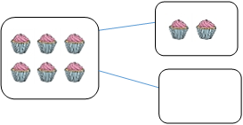  6 – 2 = 4 | 5  10  Move to using numbers within the part whole model.

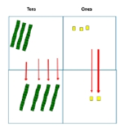
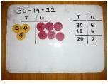
Yr/  Step | Strategy/  Method | New Vocabulary  for the Stage | Concrete | Pictorial | Abstract
Step 5  Yr 1  Yr 2 | Make 10 | Ten frame Remaining Take off Count back | 14 – 5 =  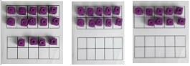  Make 14 on the ten frame. Take away the four first to make 10 and  then takeaway one more so you have  taken away 5. You are left with the answer of 9. | Start at 13. Count back 3 to reach 10. Then count back the remaining 4 so you have taken away 7 altogether.  You have reached your answer.  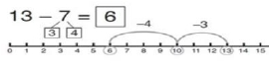 | 16 – 8 =  How many do we take off to reach the previous 10? (6)  How many do we have left to take off? (2)
Step 6  Yr 2 | Column method without  regrouping | Column Partition Larger | 75 - 42  Use Base 10 to make the bigger number  then take the smaller  number away.  Show how you partition numbers to subtract.  Again make the larger number first. | Draw the Base 10 or place value counters alongside the written calculation to help to show working:  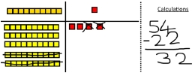  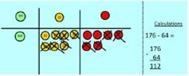 | Partitioned numbers are written vertically:  For 54 – 22  Tens Ones  50 4  - 20 2  30 + 2 = 32  This will lead to a clear written column subtraction:  32  - 12  20

Yr/  Step | Strategy/  Method | New Vocabulary  for the Stage | Concrete | Pictorial | Abstract
Step 7  Yr 3 (3  digits)  Yr 4 (4  digits)  Yr 5 + (4+  digits and  decimals with same np. dp)  Yr 6 (decimals with difft no. dp) | Column method with  regrouping | Exchange Partition | Use Base 10 to start with before moving on to place value counters. Start with one exchange before moving onto subtractions with 2  exchanges.  Make the larger number with the place value counters.  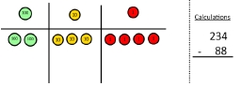  Start with the ones, can I take away 8 from 4 easily? I can’t take away 8 ones. I need to exchange one of my  tens for ten ones.  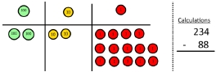  Now I can subtract 8 ones from 14. Next look at the tens. I can’t take away 8 tens. I need to exchange a hundred for 10 tens: | Draw the counters onto a place value grid and show what you have taken away by crossing the counters out as well as clearly showing the exchanges you make:  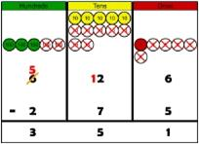  When confident, children can find their own way to record the exchange/regrouping:  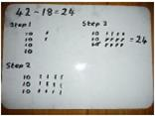  Just writing the numbers as shown here shows that the child | 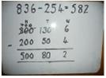  Children can start their formal written method by partitioning the number into clear place value columns.  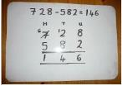  Moving forward the children use a more compact method.  This will lead to an understanding of  subtracting any number including decimals:

 |  |  | 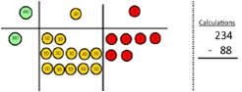  Now I can take eight tens from the 12 tens and complete the subtraction.  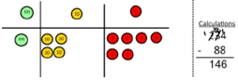  Show children how the concrete method links to the written method alongside their working. Cross out  the numbers when exchanging and show where we write our new amount. | understands the method and knows when to exchange/regroup. | 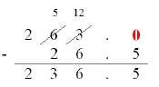

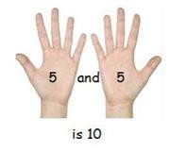
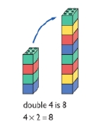


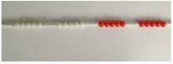
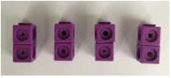
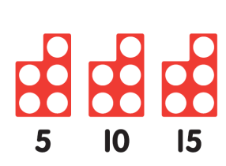
Multiplication

Yr/  Step | Strategy/  Method | New Vocabulary  for the Stage | Concrete | Pictorial | Abstract
Step 1  Yr R Yr 1  Yr 2 | Doubling | Double  Count on (from, to) Count back (from, to Count in ones, twos, tens…  Is the same as | Use practical activities to show how to double a number. | Draw pictures to show how to double a number. | 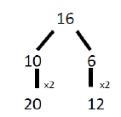  Partition a number and then double each part before recombining it back together.  4 x 2 = 8
Step 2  Yr R Yr 1 +  Yr 2  (x2, 5,  10)  Yr3 (x3, 4,  8) | Counting in multiples | Multiplied by The product of Groups of  Lots of  Is equal to | Count in multiples supported by concrete objects in equal groups. | 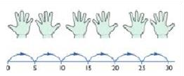  Use a number line or pictures to continue support in counting in multiples. | Count out loud in multiples of a number.  Write sequences with multiples of numbers.  2, 4, 6, 8, 10  5, 10, 15, 20, 25 , 30

Yr/ Step | Strategy/ Method | New Vocabulary for  the Stage | Concrete | Pictorial | Abstract
 |  |  | Use different objects to add equal  groups. | There are 3 plates. Each plate has 2 star biscuits on. How many biscuits are  there?    2 add 2 add 2 equals 6  Repeated addition can be shown on a labelled or empty number line.  Eg 5 + 5 + 5 = 15:  5 5 5  0 1 2 3 4 5 6 7 8 9 10 11 12 13 14 15  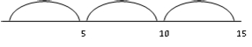  Begin to relate repeated addition to multiplication using ‘lots of’.  e.g. 3 lots of 5 = 15 | Write addition sentences to describe  objects and pictures.
 |  |  | 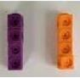 |  | 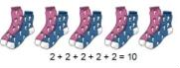
Step 3 |  |  | 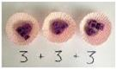 |  | This then leads to writing related multiplication sentences  e.g. 2 x 5 = 10
Yr 2 | Repeated addition
Yr 3

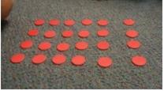
Yr/  Step | Strategy/  Method | New Vocabulary  for the Stage | Concrete | Pictorial | Abstract
Step 4  (Yr 1)  Yr 2  Yr 3 | Arrays - showing commutative multiplication | Array Commutative | Create arrays using counters /cubes  /numicon to show multiplication  sentences. Eg 4 x 6 = 24    Begin to look at arrays in different orientations to make the link between.  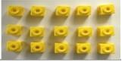  Eg 5 x 3 = 15 and 3 x 5 = 15 (commutativity) | Draw arrays in different rotations to find commutative multiplication sentences.  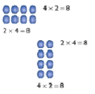  Link arrays to area of rectangles:  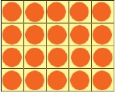 | Use an array to write multiplication sentences and reinforce repeated addition.    5 + 5+5 = 15  3 + 3 + 3 + 3 + 3 = 15  5 x 3 = 15  3 x 5 = 15

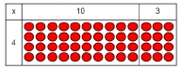
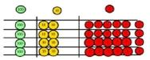
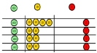
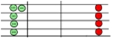
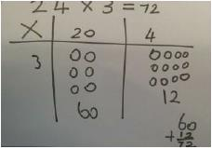
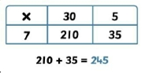
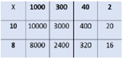
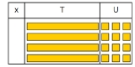
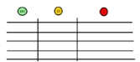
Yr/ Step

Step 5

Yr 3
Strategy/ Method

Grid Method
New Vocabulary for the Stage

Grid

Exchange

Concrete

Show the link with arrays to first introduce the grid method. Eg 4 x 13 4 rows of 10; 4 rows of 3

Move on to using Base 10 to move towards a more compact method:

4 rows of 13

Move on to place value counters to show how we are finding groups of a
number. Here, we are multiplying 126
by 4 so we need 4
rows with each containing 26. Fill each row with 126.

Add up each column, starting with the ones making any exchanges needed. Then you have your answer.

Pictorial

Children can represent the work they have done with place value counters in a way that they understand.

They can draw the counters, using
colours to show different amounts or just use circles in the different columns to show their thinking as shown below:

Abstract

Start with multiplying 2-digit by 1-digit numbers and showing the addition alongside the grid:

Moving forward, multiply by 2, 3 and 4- digit numbers showing the different rows within the grid method:
13 x 28
280
+ 84
364 1

X | 20 | 8
10 | 200 | 80
3 | 60 | 24

Eg 1342 x 18

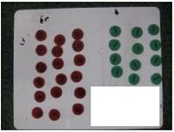
Yr/  Step | Strategy/  Method | New Vocabulary  for the Stage | Concrete | Pictorial | Abstract
Step 6  Yr4 (2  and 3 digit x 1  digit)  Yr 5 (4  digits x 1 or  2  digits)  Yr 6 (4  digits x 2  digits) | Column  multiplication | Column  multiplication | Children can continue to be supported by place value counters for carrying out column multiplication.  They can partition and record each calculation vertically.  4 x 3 = 12  60 x 3 = 180  64 x 3 = 192  It is important at this stage that they always multiply the ones first and note down their answer followed by the tens which they note below.  The idea of exchanging will support them in moving on to a more  compact method: Eg 3 x 324  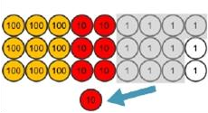 | Bar modelling and number lines can support learners when solving problems with multiplication alongside the formal written methods.  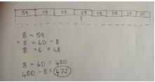  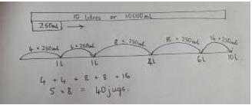  As with stage 4, children can represent the work they have done with place value counters in a way that they understand.  They can draw the counters, using colours to show different amounts or just use circles in the different columns to show their thinking. | Start with long multiplication, reminding the children about lining up their numbers clearly in columns. As with the grid method, numbers of more than one digit are partitioned but this time the calculation is recorded vertically. To support them, children need to write out what they are solving next to their answer.  Eg 38 x 7  38  X 7  56 (8 x 7)  210 (30 x 7)  266  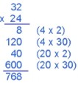  This moves to the more compact method, examples shown overleaf.

Start by multiplying the ones digit, recording the last digit of the answer in the answer line but exchanging any tens and putting them under the tens column to be added on after multiplying the tens digit. Again, the last digit in the answer is recorded in the answer line and any hundred are exchanged, this time to the hundreds column, and so on.

Eg 38 x 7
38
X 7

266

5

Eg 38 x 27
38
X 27

266 (38 x 7)
760 (38 x 20)

1026

1

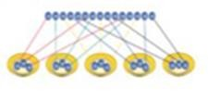





Division

Yr/  Step | Strategy/  Method | New Vocabulary  for the Stage | Concrete | Pictorial | Abstract
 |  | Half | 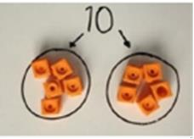 | One sweet for you, one for me…  Is it fair? How many do we each have?
Step  1 |  | Halve  Count out
Yr R | Halving | Share out Left  Left over |  | 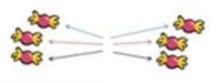
 |  | …is the same as
 |  | Equal
 |  | Share | I have 10 cubes; can you share them equally into 2 groups?  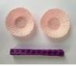  15 shared between 5 is 3: | Children use pictures or shapes to share quantities. | Share 9 buns between three People:  9 ÷ 3 = 3
 |  | Group |  |  | Share 9 buns between three People:  9 ÷ 3 = 3
Step 2  Yr R Yr 1 | Sharing objects Equally | Divide Half Halve Count out Share out  Left |  | 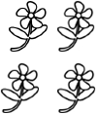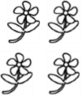  8 ÷ 2 = 4 | Share 9 buns between three People:  9 ÷ 3 = 3
 |  | Left over  Is the same as Is equal to |  | How many groups of 4 are there in 12 stars? | Share 9 buns between three People:  9 ÷ 3 = 3

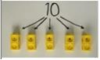
Yr/  Step | Strategy/  Method | New Vocabulary  for the Stage | Concrete | Pictorial | Abstract
 |  |  | Divide quantities into equal groups.  Use cubes, counters, objects or place value counters to aid understanding. | Use a number line to show jumps in  groups. The number of jumps equals the number of groups. | 28 ÷ 7 = 4  Divide 28 into 7 groups. How many are in each group?
Step 3  Yr 1  Yr 2 | Division as grouping | Equal groups | There are 10 sweets. How many people can have 2  sweets each?  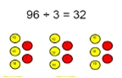   | 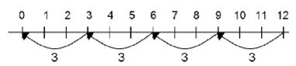  Think of the bar as a whole. Split it into the number of groups you are  dividing by and work out how many would be within each group.  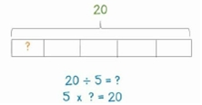
Step 4  Yr 2  Yr 3  Yr 4 | Division within arrays | Array  Inverse | Link division to multiplication by creating an array and thinking about the number sentences that can be created:  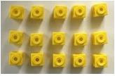  Eg 15 ÷ 3 = 5 5 x 3 = 15 | 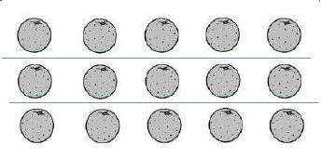  Draw an array and use lines to split the array into groups to make  multiplication and division sentences. | Find the inverse of multiplication and division sentences by creating four linking number sentences.  7 x 4 = 28  4 x 7 = 28  28 ÷ 7 = 4  28 ÷ 4 = 7
 |  |  | 15 ÷ 5 = 3 3 x 5 = 15

Yr/  Step | Strategy/  Method | New Vocabulary  for the Stage | Concrete | Pictorial | Abstract
 |  |  | 14 ÷ 3 =  Divide objects into groups or share equally and see how much is left over: | Draw dots and group them to divide an amount and clearly show a remainder: | Children use knowledge of times  table facts to quickly calculate divisions involving remainders.  For example:  27 ÷ 5 = 5 r2  Go on to combining knowledge of times tables with place value to calculate more difficult divisions.  For example:  137 ÷ 4 = 34 r1
Step 5 |  |  | 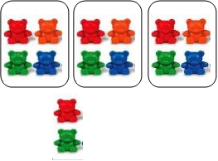 | 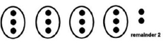  Jump forward in equal jumps on a number line then see how many more you need to jump to find a remainder.
Yr 3  Yr 4 | Division with a remainder | Remainder Equal jumps |  | 13 ÷ 4 = 3 r1  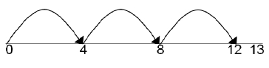
 |  |  |  | As knowledge of place value improves, children can begin to
 |  |  |  | jump in multiples of 10:
 |  |  |  | 63 ÷ 2 = 30 r3
 |  |  |  | 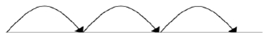
 |  |  |  | 0 20 40 60 63

Yr/  Step | Strategy/  Method | New Vocabulary  for the Stage | Concrete | Pictorial | Abstract
Step 6  Yr3 (2  digit by 1 digit)  Yr4 (up to 3  digits by 1 digit)  Yr5 (up to 4  digits by a 1 digit  remain der.  Interpr et  remain ders based on  contex t) | Short division | Bus stop method | Use place value counters to divide using the bus stop method alongside:  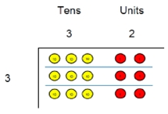  42 ÷ 3=  Start with the biggest place value; we are sharing 40 into three groups. We can put 1 ten in each group and we have 1 ten left over:  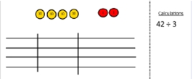  We exchange this ten for ten ones and then share the ones equally among the groups:  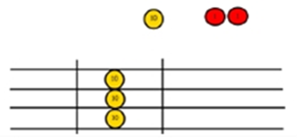 | Children can continue to use drawn diagrams with dots or circles to help them divide numbers into equal groups.  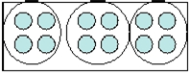  Encourage them to move towards counting in multiples to divide more efficiently. | Begin with divisions that divide equally with no remainder:  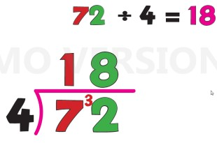  872 ÷ 4 = 218:  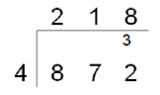  Move onto divisions with a remainder:  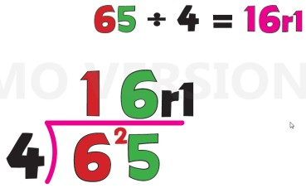  432 ÷ 5 = 86 r2:  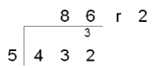

 |  |  | We look at how much is in 1 group so the answer is 14:  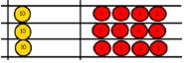 |  | Finally move into decimal places to divide the total accurately.  511 ÷ 35 = 14.6:  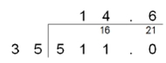  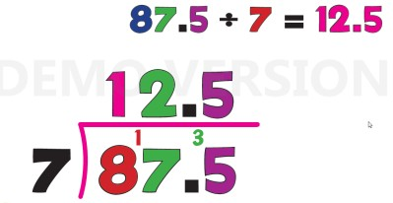

Yr/  Step | Strategy/  Method | New Vocabulary  for the Stage | Concrete | Pictorial | Abstract
Step 7  Yr6 (up to 4  digits by a 2 digit  remai nder. Interp ret  remai nders as  whole numb ers, fractio ns or  round  ) | Long division |  | It is recommended that instead of using physical counters, students can draw the counters and circle the groups on a whiteboard or in their books.  If needed:  71 ÷ 3 =  Using Base 10 or place value counters, we start with 7 tens and 1 one, to be divided into 3 groups. We can put 2 tens in each group, so we write a 2 in the tens column. In all, we've put 6 tens into the groups (3 x 2 tens), so we write 6 tens (60) below.  We are left with 11 (1 ten and 1 one). We will need to exchange the ten for 10 ones so we can put 3 ones in each group (using 9 ones in all), and we will have a remainder of 2.  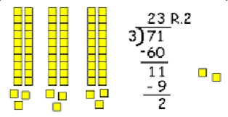 | Use this method to explain what is happening and as soon as they have understood what move on to the abstract method as this can be a time consuming process:  Eg. 2544 ÷ 12  How many groups of 12 thousands do we have? None  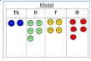  Exchange 2 thousand for 20 hundreds:  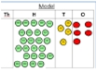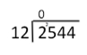  How many groups of 12 are in 25 hundreds? 2 groups. Circle them. | 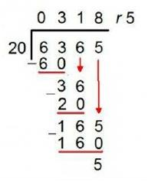  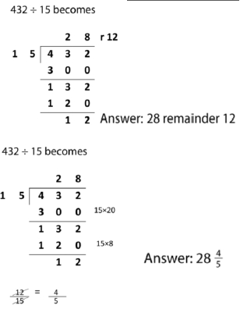

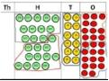
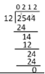
 |  |  |  | We have grouped 24 hundreds so can take them off and we are left with one:  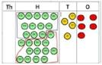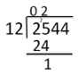  Exchange the one hundred for ten tens so now we have 14 tens. How many groups of 12 are in 14? 1  remainder 2:  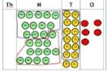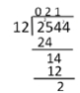  Exchange the two tens for twenty ones so now we have 24 ones. How many groups of 12 are in 24? 2 | 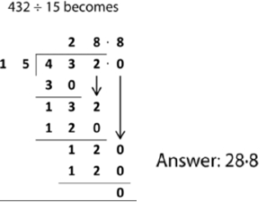

Appendix: Additional guidance adapted from ‘Calculation guidance’ by NCETM, published October 2015.

Develop children’s fluency with basic number facts

Fluency is dependent upon accurate and rapid recall of basic number bonds to 20 and times-tables facts. A short time everyday on these basic facts quickly leads to improved

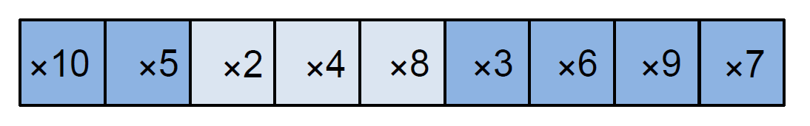
fluency. This can be done using simple whole class chorus chanting. The is not meaningless rote learning; rather, this is an important step to developing conceptual understanding through identifying patterns and relationships between the tables (for example, that the products in the 6× table are double the products in the 3× table). This helps children develop a strong sense of number relationships, an important prerequisite for procedural fluency.

Children in Shanghai learn their multiplication tables in this order to provide opportunities to make connections:
At St Mark’s, we expect such facts to be practised for a short time each day.

Develop children’s fluency in mental calculation (The Magic 10)

Efficiency in calculation requires having a variety of mental strategies. In particular the importance of 10 and partitioning numbers to bridge through 10 should be emphasised. For example:

9 + 6 = 9 + 1 + 5 = 10 + 5 = 15.

This is referred to as the “magic 10”. It is helpful to make a 10 as this makes the calculation easier. Young children benefit from being helped at an early stage to start calculating, rather than relying on ‘counting on’ as a way of calculating. For example, with a sum such as:

4+ 7=

Rather than starting at 4 and counting on 7, children could use their knowledge and bridge to 10 to deduce that because 4 + 6 = 10, so 4 + 7 must equal 11.

Develop children’s understanding of the = symbol

The symbol = is an assertion of equivalence. If we write: 3+ 4 = 6 + 1

then we are saying that what is on the left of the = symbol is necessarily equivalent to what is on the right of the symbol. But many children interpret = as being simply an instruction to evaluate a calculation, as a result of always seeing it used thus:

3+ 4=

5×7=

16 – 9 =

If children only think of = as meaning “work out the answer to this calculation” then they are likely to get confused by empty box questions such as: 3 + □= 8
Later they are very likely to struggle with even simple algebraic equations, such as:

3y = 18

One way to model equivalence such as 2 + 3 = 5 is to use balance scales.

Chinese textbooks vary the position of the = symbol and include empty box problems from Grade 1 (equivalent to Year 2 in England) to deepen children’s understanding of the = symbol.

Use intelligent practice

Chinese children engage in a significant amount of practice of mathematics through class and homework exercises. However, in designing these exercises, the teacher is advised to avoid mechanical repetition and to create an appropriate path for practising the thinking process with increasing creativity (Gu, 1991). The practice that Chinese children engage in provides the opportunity to develop both procedural and conceptual fluency. Children are required to reason and make connections between calculations. The connections made improve their fluency. For example:
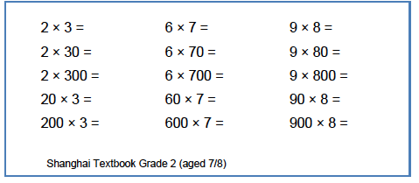

Move between the concrete and the abstract

Children’s conceptual understanding and fluency is strengthened if they experience concrete, visual and abstract representations of a concept during a lesson. Moving between the concrete and the abstract helps children to connect abstract symbols with familiar contexts, thus providing the opportunity to make sense of, and develop fluency in the use of, abstract symbols. For example, in a lesson about addition of fractions children could be asked to draw a picture to represent the sum:
Alternatively, or in a subsequent lesson, they could be asked to discuss which of three visual images correctly represents the sum, and to explain their reasoning:
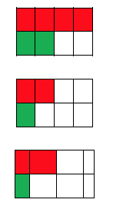

Contextualise the mathematics

A lesson about addition and subtraction could start with this contextual story:

“There are 11 people on a bus. At the next stop 4 people get on. At the next stop 6 people get off. How many are now on the bus?”

This helps children develop their understanding of the concepts of addition and subtraction. But during the lesson the teacher should keep returning to the story. For example, if the children are thinking about this calculation:

14 – 8

then the teacher should ask the children:

“What does the 14 mean? What does the 8 mean?”, expecting that children will answer: “There were 14 people on the bus, and 8 is the number who got off.”

Then asking the children to interpret the meaning of the terms in a sum such as 7 + 7 = 14 will give a good assessment of the depth of their conceptual understanding and their ability to link the concrete and abstract representations of mathematics.

