
St. Mark’s C. E. Primary School, Staplefield
Collective Worship Policy

Adopted: Spring 2024
Next Review: Spring 2027

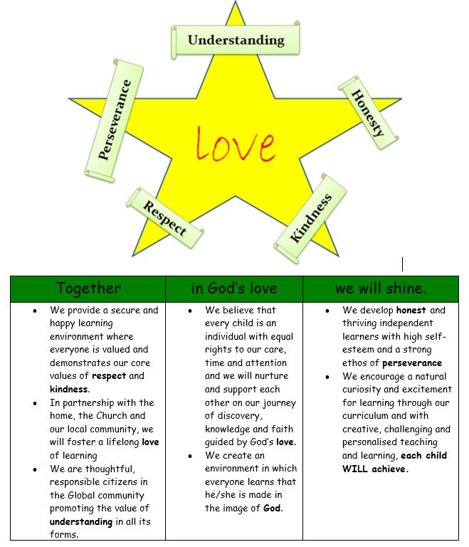

St Mark’s School is a Voluntary Controlled Church of England Primary School and, as such, has a Christian tradition and ethos. Our collective worship reflects and reinforces the schools, vision aims and ethos that, ‘Together, In God’s Love, We Will Shine’. Our collective worship both implicitly, and explicitly, demonstrates our Christian values of love, understanding, perseverance, honesty, kindness and respect. This document has been written with an especial awareness of the Church of England’s 2016 Vision for Education and 2021’s Inclusive, Invitational, Inspiring document on collective worship.

At St. Mark's school we consider collective worship to be an important part of the school day. An opportunity to reflect and develop the school’s distinctive Christian character but also an opportunity to contribute to the academic achievement, personal development and well-being of pupils and staff.

Aims of our acts of collective worship.
We aim for our collective worship to
- a) Be a daily expression of our school’s Christian vision.
- b) Be inclusive, invitational and inspiring for all pupils, staff and parents and visitors
- c) Empower our children and community to see themselves as agents for change in their world and activists in challenging all forms of injustice and prejudice
- d) Offer the opportunity, without compulsion, to all pupils and adults to grow spiritually through experiences of prayer, stillness, worship and reflection
- e) Enable all pupils and adults to appreciate that Christians worship in different ways, for example using music, silence, story, prayer, reflection, the varied liturgical and other traditions of Anglican worship, festivals and, where appropriate, the Eucharist.
- f) Help pupils and adults to appreciate the relevance of faith in today’s world, to encounter the teachings of Jesus and the Bible and to develop their understanding of the Christian belief in the Trinitarian nature of God and its language.
- g) Enable pupils as well as adults to engage in the planning, leading and evaluation of collective worship in ways that lead to improving practice. Leaders of worship, including clergy, have access to regular training.
- h) Encourage local church community partnerships to support the school effectively in developing its provision for collective worship.

Collective worship includes the educational opportunities for
- a) the whole community to celebrate;
- b) sharing and experiencing differences;
- c) developing a culture of learning;
- d) building a sense of group identity;
- e) encouraging a sense of personal and social responsibility;
- f) a break from the busyness of life (for stillness and quiet);
- g) learning how to behave in a large social group;
- h) exploring feelings and emotions;
- i) learning how to perform in front of an audience;
- j) learning how to respond to a performance;
- k) making visible the school’s leadership;
- l) developing inner awareness.
- m) upholding British Values and supplementing them with the awareness of the right to participate in peaceful protest and dissent.
- n) Acknowledging the Equality Act and protective characteristics in providing a template for a more just world.

Legal Requirements
The law requires the Headteacher and Governing Body to provide a daily act of collective worship which is in line with the school’s Trust Deed and Foundation. The school meets with requirement. This requirement is explained to all involved in the planning and delivery of acts of worship.
Right of Withdrawal
Parents have the right to withdraw their children from acts of worship and this is stated in the school prospectus and handbook. NB. In a controlled school (or if they were first employed when the school was a controlled school), staff have the right to withdraw from the act of collective worship. It is intended that consultation will take place before formal requests are made to withdraw from acts of worship. In the case of parents or teachers contact needs to be made with the Headteacher. Guidance for new parents on non-participation in acts of Collective Worship is given in the school prospectus.

Planning of Collective Worship
See Appendix 1 for the organisation of collective worship for the current academic year.
The St. Mark's Headteacher, Co- Headteacher, Parish Priest and student Vision in Action Committee plan the worship based on the two-year rolling programme, and then creates a more detailed half termly plan taking account of school activities, festivals and import events.
The person leading the collective worship is expected to plan their worship as carefully as they would a lesson. Resources used include Big Start Assemblies, Picture News, ‘Christian values 4 schools’ website and links taken from the theological strands of RE study at the time.
Pupils are involved in planning and leading Collective Worship by setting up all acts of worship and leading worship on many Friday sessions.

Class worship takes place on Thursday and further addresses the spiritual and moral themes raised in the Headteacher’s Monday worship session.

Themes
We take the themes of our Collective Worship from the two-year rolling programme based on Christian values, what’s occurring in current affairs and our response to events. In addition, each term the festivals and events of the Christian calendar are included.

Visitors
We welcome visitors to our collective worship. Some visitors are invited to share their experiences, linked to the theme of the collective worship, other visitors present a whole collective worship on a theme requested by the Headteacher. We welcome the Revd. Carl Smith every week.
Visitors should understand that in schools E is for Education not Evangelism and avoid proselytising. Attempts to persuade pupils to adopt a particular religious or non-religious belief are not appropriate. Visitors should not speak about raising money for any particular cause without the prior permission of the headteacher.

Governors
Collective Worship is taken by our local vicar (who is also a governor) on Tuesdays. We also welcome Governors’ attendance at our assemblies at any time.

Monitoring, Review and Inspection
It is the role of the Governors to monitor the policy and practice of collective worship.
The materials for worship are stored in a folder on the staff’s shared drive and the efficacy of worship practice discussed termly by staff and SLT.

The Co-Headteacher seeks feedback from the children and staff about collective worship every term.

The School will also be inspected through Section 48 SIAMS inspection.

Appendix 1 Organisation of Collective Worship for the academic year 2024-25

We hold a daily act of worship in our School, taking various forms:

The exact day that the style of worship takes place may vary depending on the activities in the school, and availability of visitors however this is the intended pattern for collective worship;

▪ Monday - Headteacher using Picture News Resources with response board for children to comment on prominent in the main corridor
▪ Tuesday - Revd. Carl Smith – Leads worship on chosen RE/Biblical theme in school or – more regularly – our parish church with parents invited to attend
▪ Wednesday – Co-Headteacher following themes from the two-year rolling programme
▪ Thursday - Class worship session following up themes from Monday’s worship
▪ Friday – Reflection on our Christian values theme, Events in the Christian calendar or Pupil led worship (VIACS)

Festival and celebrations in the church
In St. Mark's school we celebrate:

Harvest
Christmas
Mother’s Day
Easter
Pentecost

Prayer Spaces
Our school VIAC is developing worship focussed spaces to work alongside established whole school reflection and outside spaces.

