Low-Level Concerns – Model Policy For Schools

1. Introduction
At St. Mark’s CE Primary, we take safeguarding very seriously and safeguarding and promoting the welfare of children is everyone’s responsibility. This includes ensuring that all adults who work with children do so in a way that is in accordance with the values, ethos and culture of the school as set out in the school’s values, Staff Behaviour Policy, Staff Code of Conduct, Whistleblowing, Acceptable Use of IT/Mobile Devices Policy. See also the government’s webpage providing Guidance On Behaviour In Schools for more information.

The purpose of this policy is to enable all staff at the school to share any low-level concerns they might have about their own or another member of staff’s behaviour with the headteacher.

To achieve this purpose, St. Mark’s Primary will ensure, through training and other appropriate means that its staff are:
- Clear about what ‘expected and appropriate behaviour’ is (as visualised in the Spectrum of Behaviour Diagram below).
- Confident in distinguishing ‘expected and appropriate behaviour’ from ‘concerning, problematic or inappropriate behaviour’ – both in themselves and others.
- Empowered to confidentially share any low-level concerns with the headteacher.
- Able to interpret the sharing of low-level concerns as a neutral act.

By doing these things the school will:
- Identify and address any ‘concerning, problematic or inappropriate behaviour’ identified as a low-level concern, including any patterns.
- Support any individual member of staff by discussing and positively influencing any ‘concerning, problematic or inappropriate behaviour’ they might have shown at an early stage.
- Respond sensitively and proportionately to the handling of low-level concerns when they are raised.
- Be able to identify any weaknesses in its safeguarding system.

2. Scope
This policy covers the following:
- Teachers (including the headteacher and members of the school’s leadership team)
- Support staff
- Supply Teachers
- Volunteers (including governors/trustees)
- Local Authority visiting staff
- Contractors
In this policy document we will generally refer to the “staff” or “school staff” to encompass all of the above.

3. Aims
This policy is a key part of the school’s over-arching aim to create and embed a culture of openness, trust, and transparency where our values are lived and the behaviours we expect from all our staff are monitored and reinforced. This policy will help the school:
- Create a culture (e.g., our ethos, values and behaviours) in which all concerns about adults are shared responsibly with the right person and are recorded and dealt with appropriately.
- Enable the school to identify concerning, problematic or inappropriate behaviour early.
- Minimise the risk of abuse occurring.
- Ensure that adults working in or on behalf of the school are clear about and act within professional boundaries.
- Create an environment where all staff are comfortable to self-refer.

4. What is a Low-Level Concern?
Source: Statutory Guidance Keeping Children Safe In Education
The term ‘low-level’ concern does not mean that it is insignificant. A low-level concern is any concern – no matter how small, and even if no more than causing a sense of unease or a ‘nagging doubt’ - that an adult working in or on behalf of the school may have acted in a way that:
- Is inconsistent with the staff code of conduct, including inappropriate conduct outside of work and
- Does not meet the harm threshold or is otherwise not serious enough to consider a referral to the Local Authority Designated Officer (LADO).
Examples of such behaviour could include, but are not limited to:
- Being over friendly with children.
- Having favourites.
- Taking photographs of children on their mobile phone, contrary to school policy.
- Engaging with a child on a one-to-one basis in a secluded area or behind a closed door.
- Humiliating pupils.
Such behaviour can exist on a wide spectrum, from the inadvertent or thoughtless, or behaviour that may look to be inappropriate, but might not be in specific circumstances, through to that which is ultimately intended to enable abuse.
Low-level concerns may arise in several ways and from a number of sources. For example: suspicion; complaint; or disclosure made by a child, parent, or other adult within or outside of the organisation; or as a result of vetting checks undertaken.
At this school, it is crucial that all low-level concerns are shared responsibly with the headteacher and recorded and dealt with appropriately. Ensuring they are dealt with effectively should also protect those working in or on behalf of the school from becoming the subject of potential false low-level concerns or misunderstandings.

5. Spectrum Of Behaviour Diagram
Source: Developing and implementing a low-level concerns policy by Farrer and Co.
See the Spectrum Of Behaviour Diagram below for more information on how low-level concerns compare to allegations and appropriate conduct.
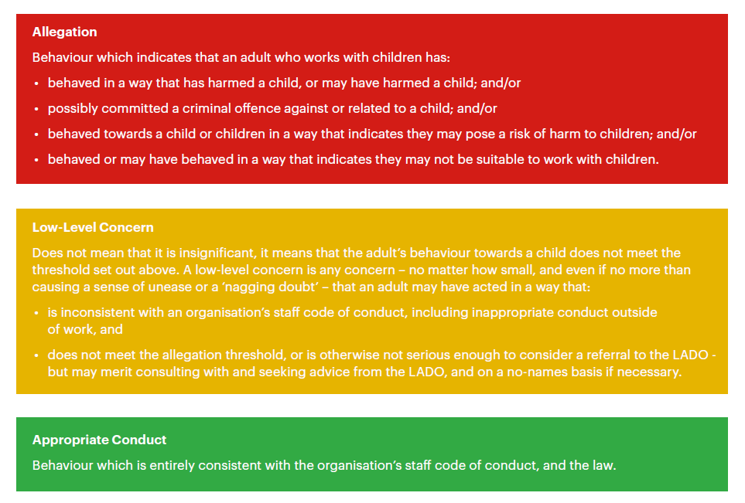

6. Avoiding Low-Level Concerns
The school recognises that education and regular reinforcement is key to our staff avoiding situations where low-level concerns might arise.

Therefore, the school will ensure new staff are clear about what allegations, low-level concerns and appropriate conduct are as set out on the Spectrum Of Behaviour Diagram during their induction.

The school will reinforce messages for all staff through regular education and training sessions which occur at least annually and through weekly staff meetings that will be underpinned by our policies and procedures e.g. Staff Code of Conduct, Safeguarding and Child Protection policies and Teachers’ Standards.

7. Reporting Low-Level Concerns
Low level concerns about a member of the school’s staff (see this policy document’s Scope above) should be reported to the headteacher.

If the low-level concern is about the headteacher this should be reported to the Chair of the Governing Body.

Low-level concerns about supply staff, contractors and local authority staff visiting the school will be reported to their respective employers through the headteacher.

8. Assessing The Report Of A Low-Level Concern
Where a low-level concern is raised, information about this must be recorded and passed to the headteacher who will make an assessment to determine if the matter is a ‘low-level concern’ or an ‘allegation’ or actually ‘appropriate conduct’ and therefore not a concern, see the Spectrum Of Behaviour Diagram above. The school will subsequently do one of the following:
- Allegations that meet the harm threshold will be referred to the LADO for advice.
- Low level concerns that the school feels may need further guidance on will be referred to the LADO for advice.
- Low level concerns that the school feels they can deal with internally will be dealt with through the school’s child protection investigation process.
- The school will engage with HR Professional where it is necessary to undertake further investigation and/or deal with the low-level concern under relevant HR policies and procedures (e.g., the Disciplinary policy)
- There will be no further action taken where the concern raised was deemed to be appropriate conduct

9. Recording Low-Level Concerns
All low-level concerns raised at the school should normally be recorded by members of staff in writing and sent to the headteacher. This can be done using the form in Appendix 1 of this policy or by email or letter. If the low-level concern is about the headteacher this should be reported to the Chair of the Governing Body by emailing the Clark, Marie Richardson.

Note: if a member of staff wishes they can report a low-level concern verbally but the person receiving the report must record the conversation as soon as possible afterwards in writing.

A low-level concern record will include:
- Details of the low-level concern.
- The context in which the low-level concern arose.
- Details of the investigation undertaken.
- Any actions taken, decisions made and outcomes.

The name of the individual sharing the details of the low-level concern should be noted, although if they wish to remain anonymous then that will be respected as far as reasonably possible.

To comply with the Data Protection Act 2018 and the UK General Data Protection Regulation (UK GDPR), records of low-level concerns will be confidential and held securely on the headteacher’s drive on the school server.

10. Reviewing Low-Level Concerns
The school’s low-level concern records will be reviewed termly by the headteacher and discussed during the DSL meetings, if appropriate, so that potential patterns of concerning, problematic or inappropriate behaviour can be identified.

If a pattern of concerning, problematic or inappropriate behaviour is identified, the headteacher will decide on the appropriate action to take. For example:
- Take advice from HR Professional Support.
- Undertake a disciplinary investigation and/or proceedings using the disciplinary policy guidance.
- Make recommendations for the member of staff concerned to receive training.
- Where a pattern of behaviour moves from a low-level concern to meeting the harm threshold, the headteacher will make a referral to the LADO.
- Review policies and training.
- Review the wider organisational culture at the school to determine if any action needs to be taken to minimise the risk of a similar pattern of concerning, problematic or inappropriate behaviour happening again.

11. References
Source: Statutory Guidance Keeping Children Safe In Education
Low-level concerns should not be included in references unless they relate to issues which would normally be included in a reference, for example, misconduct or poor performance. It follows that a low-level concern which relates exclusively to safeguarding (and not to misconduct or poor performance) should not be referred to in a reference. However, where a low-level concern (or group of concerns) meets the harm threshold for referral to the LADO and found to be substantiated, it should be referred to in a reference.

END OF MAIN BODY OF DOCUMENT, APPENDIX FOLLOWS
DOCUMENT CREATED BY KMG SHRS 19/08/2022 AND FINALISED 02/12/2022

Appendix 1: Low-Level Concern Form - Template
CONFIDENTIAL ONCE COMPLETED

St. Mark’s Primary LOW-LEVEL CONCERN FORM

Your Name

Your Role

Date and time form was completed

DETAILS OF INDIVIDUAL WHOM THE CONCERN IS ABOUT (or yourself if self-reporting)
Their Name

Their Role

Your relationship to the individual at the school (e.g., manager, colleague)

DETAILS OF LOW-LEVEL CONCERN
Please include as much detail as possible. Think about the following: What behaviour and/or incident are you reporting? What exactly happened? Why does the behaviour and/or incident worry you? Why do you believe the behaviour and/or incident is not consistent with our school’s Staff Code of Conduct?

DETAILS OF ANY CHILDREN INVOLVED
Their name(s)

FOR USE BY HEADTEACHER ONLY
Date and time low-level concern form received

Signature

Role

Actions to be taken and follow-up notes

CONFIDENTIAL ONCE COMPLETED
Note: This record will be held securely in accordance with the school’s Low-Level Concerns Policy. Low-level concerns will be treated in confidence as far as possible, but the school may in certain circumstances be subject to legal reporting requirements or other legal obligations to share information with appropriate persons, including legal claims and formal investigations.
END OF LOW-LEVEL CONCERN FORM CREATED BY KMG SHRS 19/08/2022 AND FINALISED 02/12/2022

