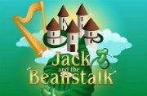
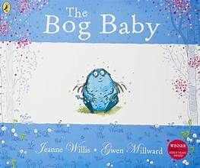
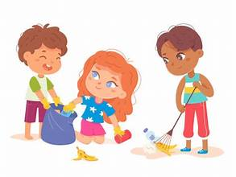
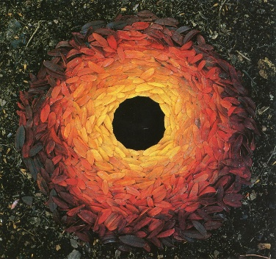
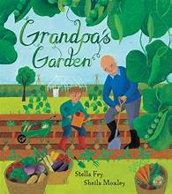
Communication and Language
This term, children will be developing their speaking and listening skills through our Voice 21 focus on Cognitive. They will learn how to use their listening skills to think of and ask relevant questions relating to what has been said. They will utilise their previously developed skills of turn taking when talking to hold a two way conversation, building on what the other person has said.
Through group discussions, storytelling, partner talk and play-based learning, children will be encouraged to speak in full sentences, share ideas, ask questions and explain their thinking.

Physical Development
Children will explore expressive movement through dance, using their bodies to communicate ideas, feelings and simple narratives. They will develop coordination, control and confidence while creating and performing short movement sequences individually and with others.
Children will develop fundamental
movement skills such as running, jumping, throwing
and catching through a range of structured and engaging games. They will learn to follow simple rules, work cooperatively and demonstrate fairness and respect towards others.

Literacy
This term, children will continue to develop their reading and writing through the Sounds-Write phonics programme, beginning with the Initial Code sound ‘ch’. They will learn new digraphs and trigraphs, building confidence in blending sounds for reading and segmenting words for spelling.
Children will apply their phonics knowledge to read simple sentences and begin writing their own phrases and sentences with increasing independence. Writing will be inspired by high-quality texts such as Grandpa’s Garden, The Bog Baby and Jack and the Beanstalk, helping children to develop vocabulary, storytelling and a love of reading.

Mathematics
Children will build on their understanding of number by exploring numbers beyond 10, developing fluency up to 20 and beyond. They will learn to solve simple addition and subtraction problems, as well as exploring grouping and sharing, helping them understand early multiplication and division concepts.
Children also investigate shape, space and measure, including composing shapes and describing position and direction. Towards the end of the term, the focus shifts to making connections, encouraging children to apply their mathematical understanding through reasoning and problem-solving in meaningful contexts.

Understanding the World
Children will learn that some everyday behaviours, such as driving short distances, can affect our local and wider environment. Children will develop an understanding of how to care for the countryside by not leaving litter, picking flowers or taking creatures from their habitats. They will explore the idea that, although environments may look different, they all need to be respected and protected. Through observing our local area, children will learn how to look closely to find out information about what a place is like.
In History, they will begin to understand the importance of looking after our world by cleaning up after themselves and leaving places better for others.

Expressive Arts and Design
Children will be inspired by the work of Andy Goldsworthy and learn how he creates artwork using natural materials. Children will create their own outdoor art using leaves, sticks, and stones, developing an appreciation for the natural world.
The children will also develop their observational drawing skills through sketching. They will learn how to look closely at objects to create detailed still life drawings, this develop their confidence in representing what they see.
Linking to The Bog Baby by Jeanne Willis, children will design and make their own Bog Baby sculptures. They will explore how to shape and combine malleable materials with natural and found objects.
In music, children will develope their listening, rhythm and performance skills.
They will learn to recognise different musical styles and instruments, and experiment with creating their own music using voices and percussion.

Personal, Social and Emotional Development
Children will learn about different types of relationships, including how to be a kind and supportive friend. Children will also explore ways to manage their emotions, understand their feelings and develop strategies to support their wellbeing.
Through discussions and activities, they will build confidence, resilience, and an understanding of how their actions can show kindness to others.

How can we show kindness to places and people?
This term, children will explore, create and discover as they learn how small actions can make a big difference to the world around them.
Through inspiring stories, hands-on experiences and creative opportunities, they will grow in confidence, curiosity and kindness. towards people and places.

