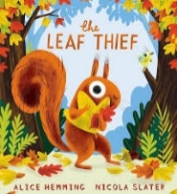
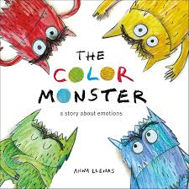
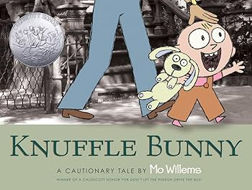
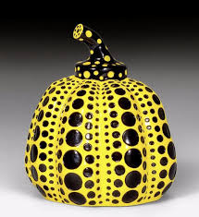
Physical Development
Children will develop their coordination, balance and spatial awareness through running, jumping and ball skills, while also strengthening their fine motor control in the classroom.
• Revise and refine the fundamental movement skills they have already acquired.
• Develop overall body strength, coordination, balance and agility.
• Develop their small motor skills so that they can use a range of tools competently.

Communication and Language
Children will enjoy high-quality stories and poems, build new vocabulary, and begin to retell stories in their own words and actions.
• Use new vocabulary throughout the day.
• Develop storylines in their play.
• Engage in Storytimes, listen to and talk about stories to build familiarity and understanding.

Mathematics
Children will explore early number concepts through matching, sorting, comparing amounts, making patterns, and developing their counting skills.
• Count objects, actions and sounds.
• Subitise (recognise quantities without counting).
• Compare numbers.
• Continue, copy and create repeating patterns.

Expressive Arts and Design
Children will explore sounds through music and instruments, as well as learn about Yayoi Kusama’s art by creating bright, patterned pumpkin paintings and sculptures.
• Explore, use and refine a variety of artistic effects.
• Return to and build on previous learning, refining ideas and developing their ability to represent them.
• Listen attentively, move to and talk about music, expressing their feelings and responses.

Why is it good to be me?
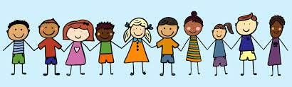
This half term we are beginning our learning journey with the question “Why is it good to be me?”. The children will be exploring their own identities, feelings and experiences, while also learning about the wider world around them. Our curriculum is carefully planned to support all areas of the Early Years Foundation Stage (EYFS), within each section we have outlined how this project links to the different areas of learning. what your child will be exploring in school and how you can support them at home.

Personal, Social and Emotional Development
Children will explore different feelings, learn how to recognise them in themselves and others, and begin to use strategies to manage and talk about their emotions.
• Identify and moderate their own feelings socially and emotionally.
• See themselves as a valuable individual.
• Build constructive and respectful relationships.

Understanding the World
Children will think about how they have grown and changed from babies to school children, notice the changes in nature as Autumn turns to Winter, and explore the question “Why is the word God so important to Christians?” through stories, objects and ideas from Christian and Muslim traditions.
• Comment on images of familiar situations in the past.
• Compare and contrast characters from stories, including figures from the past.
• Understand the effect of changing seasons on the natural world around them.
• Recognise that people have different beliefs and celebrate special times in different ways.

Literacy
Children will begin learning to recognise and say individual sounds (phonemes), blend them together to read simple CVC words (like “cat”, “dog”, “sit”), and practise segmenting words into sounds; they will also start to see that some sounds are spelled in more than one way (for example /k/ with c, k or ck).

